Transformation → Reposition and Resizing of an **object.**

Object → Set of points

1. **Translation**
2. Scaling
3. **Rotation**
4. Reflection
5. Shearing

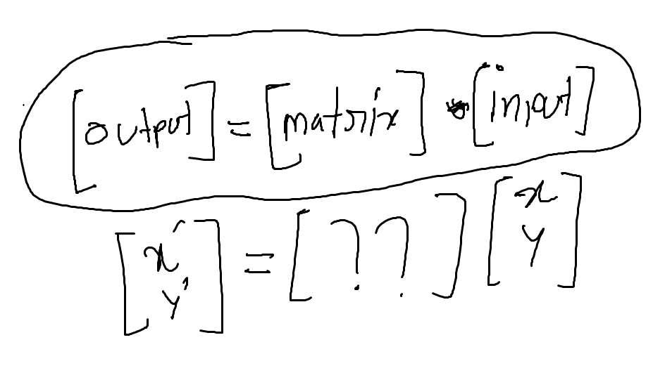

**Cartesian Representation**

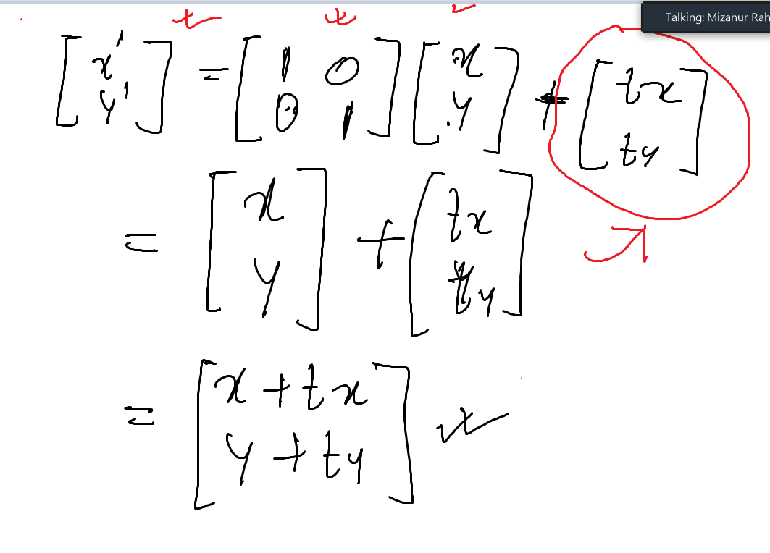

**Homogeneous Representation**

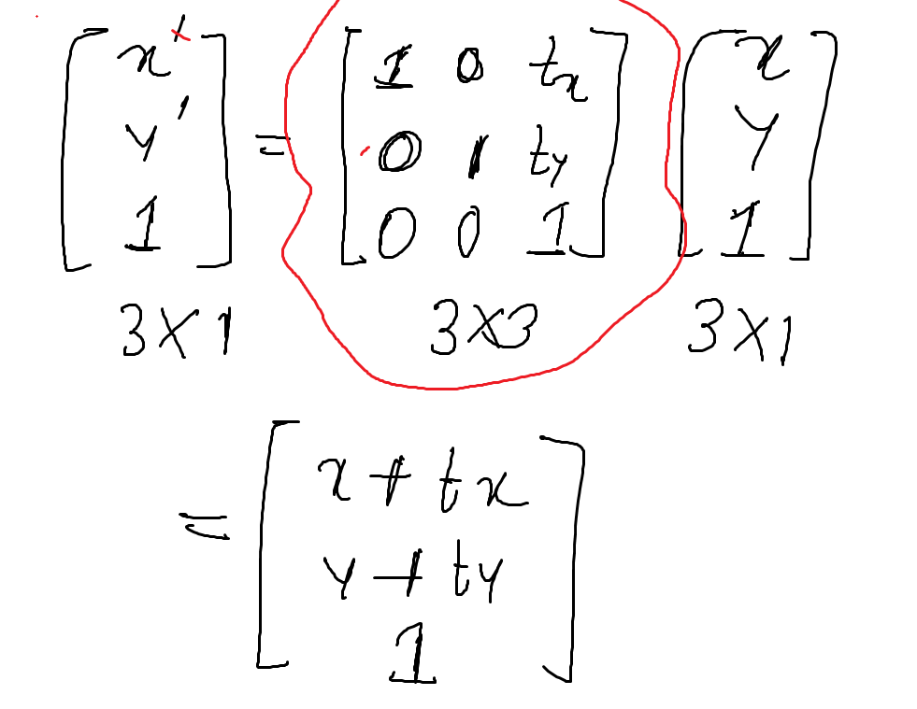

Translate point (3,2,7) → 3 units in x axis, 4 units in y axis and -3 unit z axis.

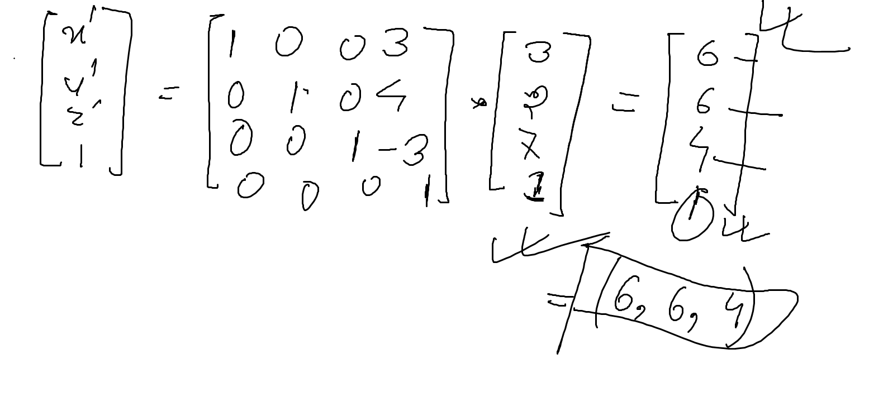

Rotation : (Z based Rotation, with respect to origin)

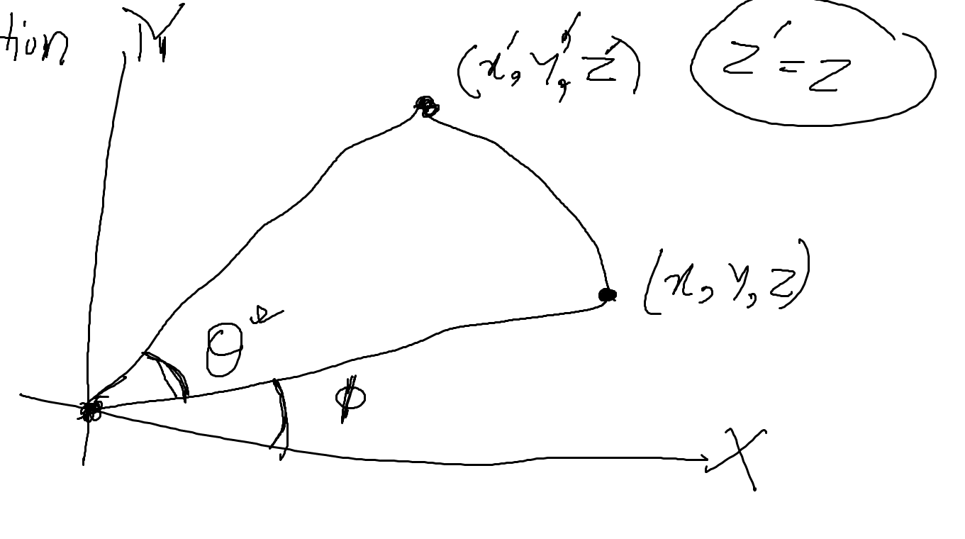

x= r cos (phi)

y= r sin (phi)

x_prime = r cos (theta + phi)

y_prime = r sin (theta + phi)

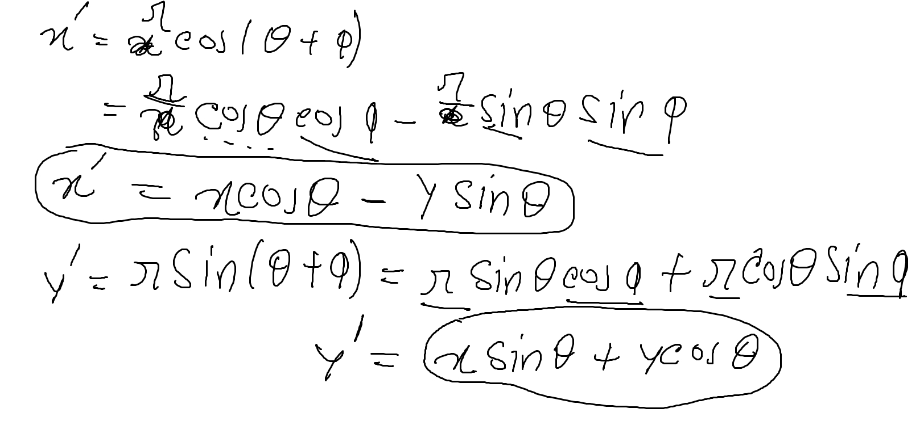

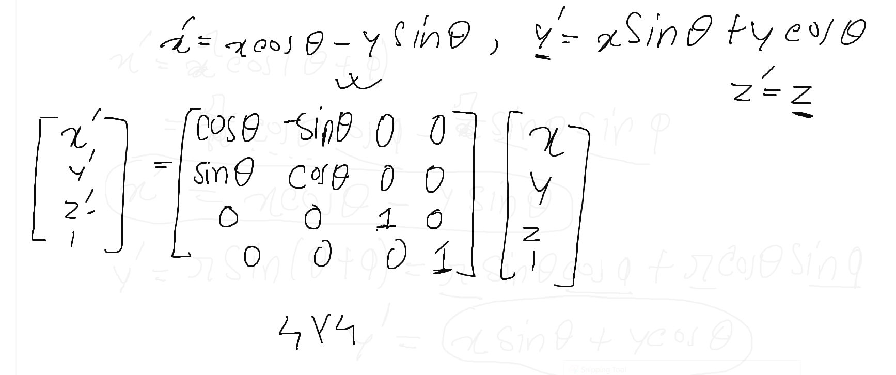

Rotate(z-based) point (9,2,5) at an angle 45 degree counterclockwise **with respect to origin**

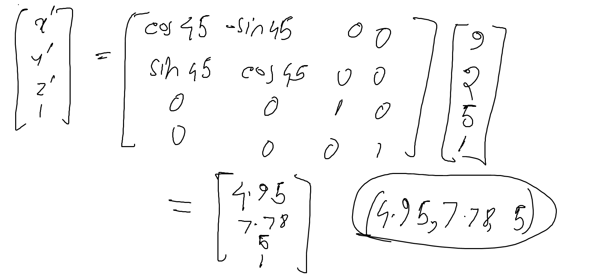

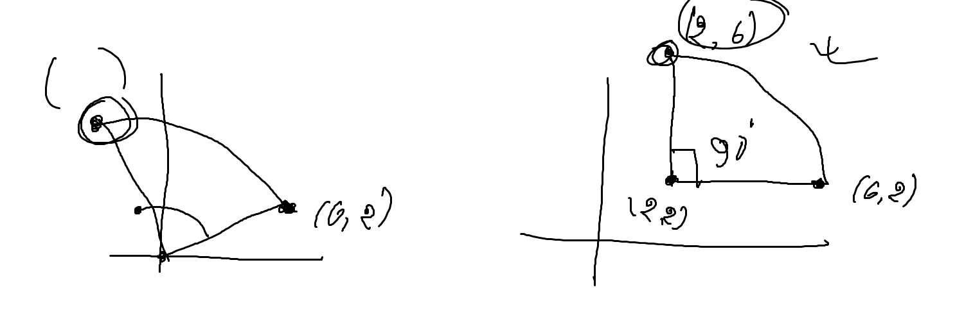

Rotate point (6,2) at an angle 90 degree counterclockwise **with respect to point (2,2)**

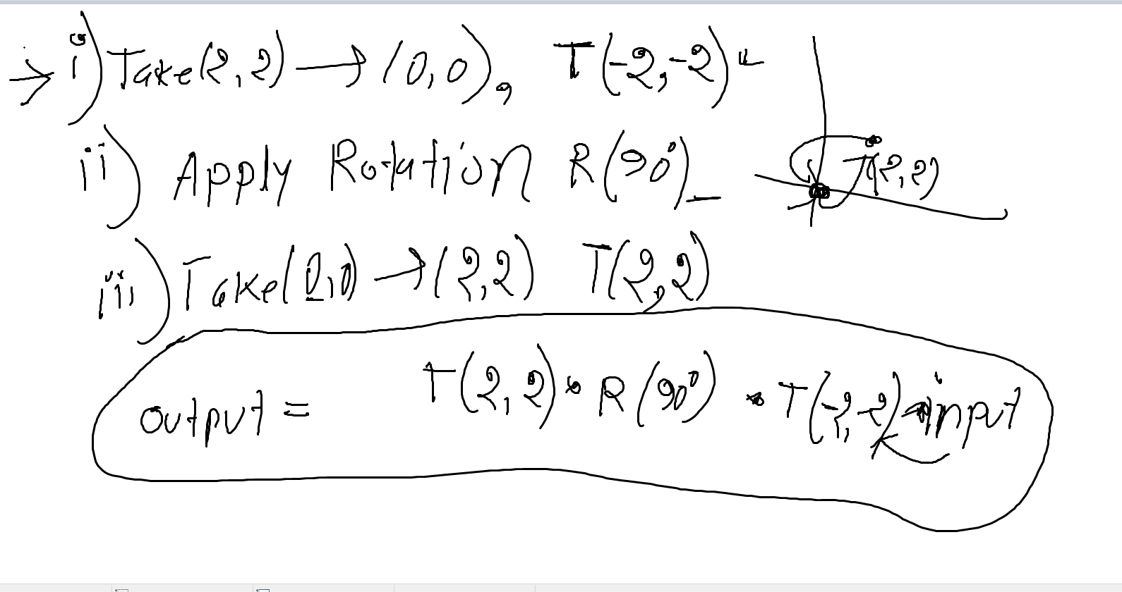

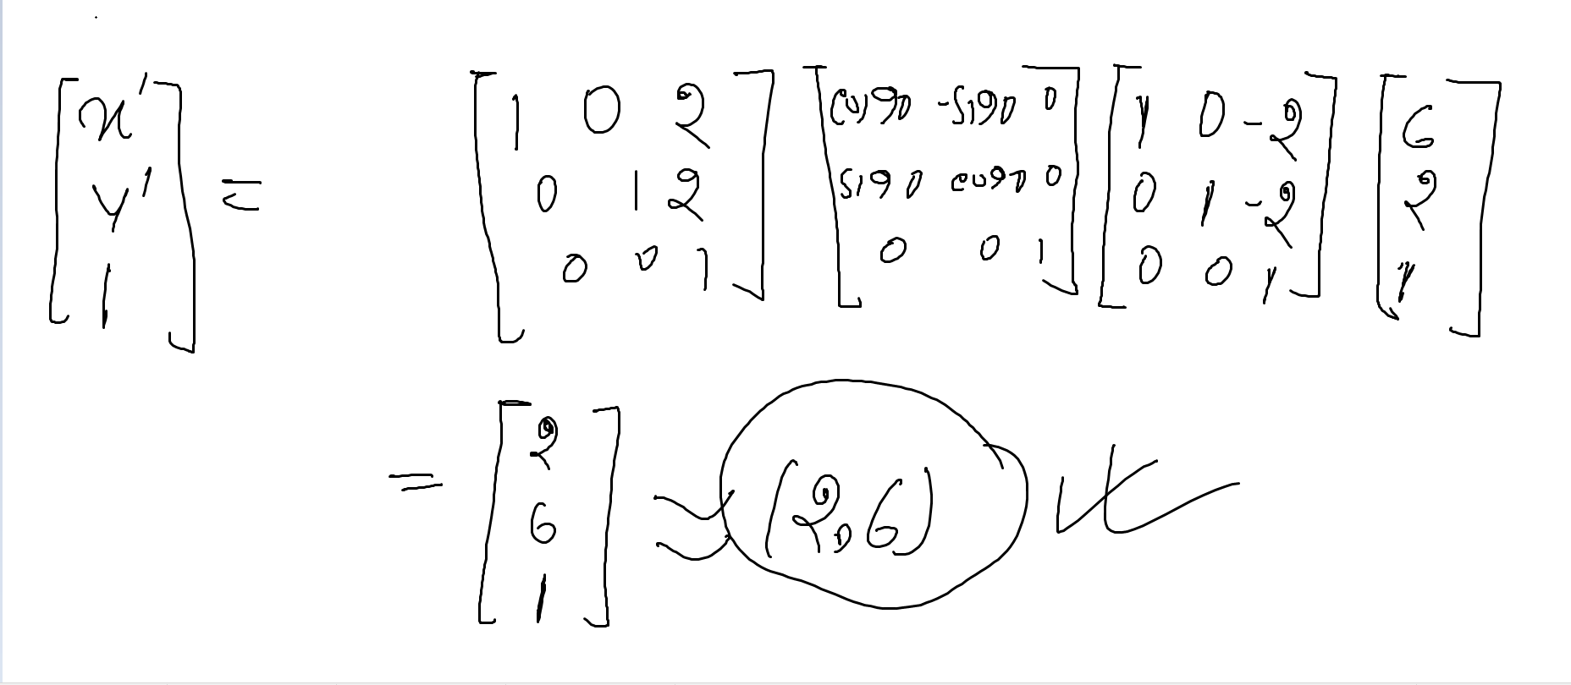

**X- based rotation / y based rotation (Self Study)**